STIC Assignment #3

Name: Ahmed Ali Raja
REG NO: 7864

Date of submission: 28/11/2025

Forward Pass
icture and finds simple patterns like edges, dark spots, light areas It creates 8 new tiny pictures (calleThe 8x8 picture starts its journey.
- First and ONLY Conv2D layer looks at the picture It uses 8 small windows (filters) Each window slides across the pd feature maps) ReLU comes right after and changes every negative number to zero – only strong patterns stay alive
- MaxPooling layer makes everything smaller It looks at every 2x2 square and keeps only the strongest number The picture size becomes 4x4 (still 8 channels)
- Flatten turns the 4x4x8 into one long line of numbers (128 numbers total)
- Dense layer (16 neurons) mixes all these numbers and thinks about them
- Final Dense layer with softmax gives a percentage for every tomato disease class Example: healthy 12%, early blight 78%, leaf mold 5%... Model says: I think this leaf has early blight
This complete trip from input picture to final answer is called Forward Pass.

Backpropagation

(finding who is responsible for the mistake)
After the model makes its guess, we check the true answer.
We calculate the loss – how wrong the guess was.
Now we send this mistake backwards through the network, from the end to the start.
- The final layer gets the biggest blame
- The Dense layer gets medium blame
- The MaxPooling layer passes the blame (it has no weights)
- The ONLY Conv2D layer gets some blame – its 8 filters are told exactly where they were wrong
This backward movement of the error is called Backpropagation.

Gradient Descent

(how the model actually learns and improves)
Every number inside the Conv2D filters and Dense layers is a weight.
Backpropagation calculated a gradient for every single weight. Gradient = a tiny arrow that says: move this weight up or down and by how much to reduce the mistake.
The Adam optimizer looks at all these gradients and gently moves every weight a very small step in the right direction.
Example: one weight inside a filter was 0.23 gradient says move down by 0.0008 after update it becomes 0.2292
All weights (about 2000 in this small model) get updated at the same time.
The model is now a little bit smarter.
We repeat forward pass + backpropagation + gradient descent many times, and accuracy slowly goes up.
That is exactly how your model learns to tell healthy tomato leaves from diseased ones using only one Conv2D layer.
CODE

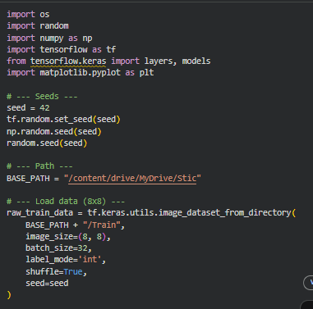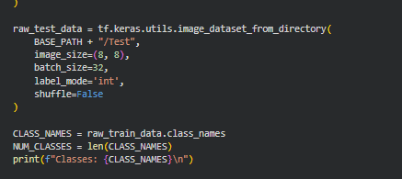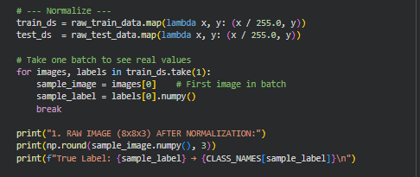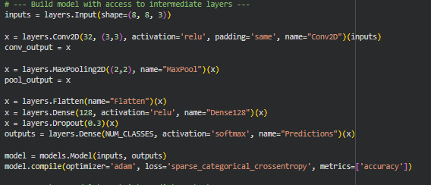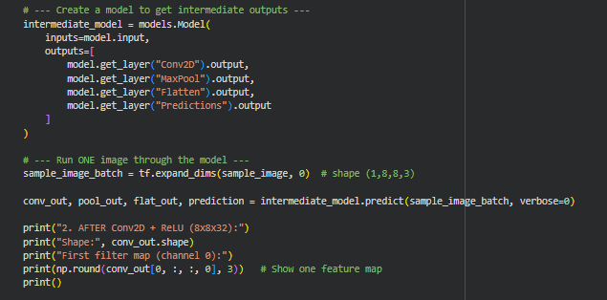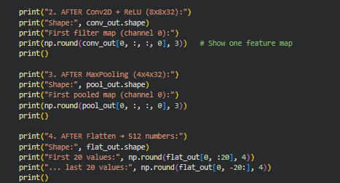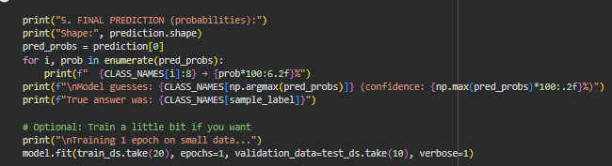

OUTPUT

